Caxton ops flow

## 

# Job Workflow for Printing Company

### **1. Job Creation & Acceptance**

* **Client Request / Order Entry**
  + Client details (name, contact, company)
  + Job type (carton, booklet, pouch folder, etc.)
  + Quantity, size, colors, finishing options
  + Deadline / Delivery date
* **Quotation & Approval**
  + Cost estimation generated
  + Client approval → Job marked as **Accepted**

### **2. Pre-Press Stage**

* **Artwork Upload / Creation**
  + Client uploads design OR in-house designer creates it
* **Proofing**
  + Proof shared with client for approval
  + Once approved → Job moves to **Production Queue**

### **3. Production Stage**

(This is where your activities like Cutting, Printing, Folding, Binding happen depending on job type)

* **Printing**
  + Digital / Offset printing begins
* **Cutting / Trimming**
  + Sheets/cartons cut to required sizes
* **Folding**
  + For booklets, folders, cartons
* **Binding / Gluing / Stitching**
  + Final assembly of booklets, pouch folders, cartons
* **Quality Check (QC)**
  + Random samples checked for print quality, alignment, finish

### **4. Post-Production**

* **Packaging**
  + Job packed safely for delivery
* **Dispatch / Logistics**
  + Courier assigned OR client pickup scheduled
* **Mark as Delivered**

### **5. Closure**

* **Client Acknowledgement**
  + Signed delivery note OR online confirmation
* **Invoice & Payment**
  + Final invoice generated
  + Payment status tracked
* **Job Closed**

## How It Works in Your Web App

* Each **Job** has a **status**:

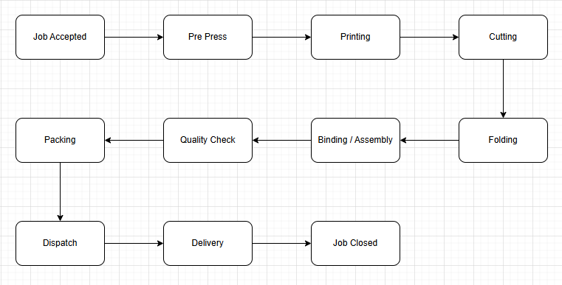

* **Deadlines / SLAs** can be attached to each stage.
* Option to **assign tasks** to team members at each stage.
* **Notifications/reminders** for delays or deadline approaching.

# Super Admin Tabs & Functionalities

## 1. **Dashboard**

* Overview of ongoing jobs (status: Pre-Press, Printing, Cutting, etc.)
* Deadlines approaching (alerts for overdue jobs)
* Completed vs Pending jobs
* Notifications (new client requests, proof approvals, dispatch updates)

## 2. **Clients**

* Add new client (name, company, contact details)
* Client list with job history
* Search/filter clients by name, company, or active jobs
* Client-specific files (artwork, past proofs, invoices)

## 3. **Jobs**

* Create New Job
  + Select client
  + Choose job type (Carton, Booklet, Folder, etc.)
  + Quantity, deadline, description
  + Upload artwork (if available)
  + Auto-generate **Task Workflow** with deadlines
* Job list with filters (status, deadline, client, type)
* Update job status manually (if needed)
* Attach proofs, artwork, or QC images
* Alerts if job stage is delayed

## 4. **Tasks**

* View all tasks across jobs (Kanban / Table view)
* Assign staff to tasks (designer, printer, binder, courier, etc.)
* Set/adjust task deadlines (auto from job OR manual override)
* Mark task as Pending, In Progress, or Completed
* Add remarks/issues for each task (e.g., “Machine breakdown, delayed”)

## 5. **Employees / Users**

* Add staff (name, role, contact, login credentials)
* Assign roles: Designer, Printer, Binder, QC, Packaging, Logistics
* See tasks assigned to each employee
* Track productivity (jobs completed, delays, QC failures)

## 6. **Invoices & Payments**

* Not in Phase 1 Development

## 7. **Reports**

* Not in Phase 1 Development

## 8. **Settings (NOT IN PHASE 1 DEVELOPMENT)**

* Configure job workflows (decide which stages apply per job type: cartons, booklets, folders)
* Default task deadlines (e.g., Printing = 5 days before delivery, Cutting = 4 days, etc.)
* Branding (company logo, name, invoice header/footer)
* Notification settings (email/SMS reminders for deadlines)
* Admin account management

# Task Example

## **How Deadlines Are Calculated**

When **job is accepted**, you can generate tasks with deadlines **based on final delivery date**.  
For example, if **Delivery deadline = 30-Sep-2025**:

* Printing → 5 days before delivery (25-Sep)
* Cutting → 4 days before delivery (26-Sep)
* Folding → 3 days before delivery (27-Sep)
* Binding → 2 days before delivery (28-Sep)
* QC → 1 day before delivery (29-Sep)
* Packaging → 1 day before delivery (29-Sep)
* Dispatch → Delivery day (30-Sep)

If the job is **Booklets** (job_type = "Booklet"):

| **Task Order** | **Stage** | **Assigned To (example)** | **Deadline** | **Status** |
| --- | --- | --- | --- | --- |
| 1 | Pre-Press | Designer | 26-Sep-2025 | Done |
| 2 | Printing | Printer Operator | 27-Sep-2025 | In Progress |
| 3 | Cutting | Machine Operator | 28-Sep-2025 | Pending |
| 4 | Folding | Folding Staff | 28-Sep-2025 | Pending |
| 5 | Binding | Binding Operator | 29-Sep-2025 | Pending |
| 6 | QC | Supervisor | 29-Sep-2025 | Pending |
| 7 | Packaging | Packaging Staff | 30-Sep-2025 | Pending |
| 8 | Dispatch | Logistics | 30-Sep-2025 | Pending |
| 9 | Delivered | Courier | 01-Oct-2025 | Pending |